Curated Piercing and High-End Jewelry Profile: Femme Lesbian (Ages 18-21)
For a young femme lesbian aged 18 to 21 with a taste for luxury, piercings serve as a canvas for intentional, highly refined self-expression. Moving far beyond casual body modification, this curation treats the body as a gallery. The aesthetic philosophy is rooted in delicate opulence, hyper-feminine symmetry, and precious metals, utilizing high-end solid 14k or 18k yellow and rose gold, handset VS-clarity diamonds, genuine pearls, and white sapphires.

The comprehensive list below details the placements, specific anatomical locations, and meticulously crafted jewelry designs.

1. The Facial Architecture

Earlobe Tier: The Constellation and Symmetry
- First Lobes:
  - Placement: Standard center of the lower earlobe.
  - Jewelry: Matching classic hoop rings crafted from 14k polished yellow gold, encrusted with an outer halo of micro-pavé set natural white diamonds. The hoops sit flush and snug against the lobe, catching the light with every turn of the head.

- Second Lobes:
  - Placement: Directly above and slightly offset behind the first lobes.
  - Jewelry: Threadless push-pin stud posts featuring genuine, perfectly round Akoya cultured pearls (4mm) suspended in handcrafted, claw-prong settings of 14k yellow gold.
- Third Lobes:
  - Placement: Upper soft tissue of the earlobe, near the cartilage boundary.
  - Jewelry: Tiny, glittering single-stone studs featuring 2mm marquise-cut white sapphires set horizontally in polished 14k gold bezels, creating a delicate, eye-catching elongation.

Cartilage Tier: Soft Edge and Curvature
- Helix:
  - Placement: Upper outer cartilage rim of the right ear.
  - Jewelry: A lightweight, seamless clicker ring in 14k rose gold featuring a dangling, teardrop-cut morganite gemstone that sways softly against the curve of the ear.
- Tragus:
  - Placement: The small, prominent flap of cartilage immediately in front of the ear canal on the left side.
  - Jewelry: A flat-back labret stud topped with a miniature 14k yellow gold flower cluster, featuring five tiny round diamonds as petals and a central microscopic gold bead.
- Conch:
  - Placement: The deep, central cup of the left ear cartilage.
  - Jewelry: A snug, sleek 14k yellow gold circular barbell or ring wrapped by a delicate chain-drape attachment that connects back up to the helix piercing, shimmering with alternating micro-beads of solid gold and bezel-set diamonds.
- Rook:
  - Placement: The uppermost ridge of inner ear cartilage.
  - Jewelry: A curved barbell made of 14k rose gold, tipped at both ends with micro-threaded spheres of polished pink opal that offer a soft, milky luster.

Facial Accents
- Nostril:
  - Placement: The curve of the right nostril.
  - Jewelry: A bespoke L-bend nose stud fashioned from 14k white gold, featuring a flat-set, 2.5mm cushion-cut diamond that sits flush against the skin, offering an understated, luminous sparkle.
- Septum:
  - Placement: The sweet spot of nasal cartilage dividing the nostrils.
  - Jewelry: A hinged segment clicker ring in 14k yellow gold, featuring an ornate, scalloped filigree design along the lower arch that hugs the base of the nose like an intricate piece of fine lace.

2. The Torso and Centerline

Oral Cavity
- Tongue:
  - Placement: Center-line vertical piercing through the muscular tissue of the tongue.
  - Jewelry: A straight implant-grade titanium barbell fitted with custom-threaded ends: a top ball encased in a smooth, high-polish 14k yellow gold cap, and a flat bottom disk designed for maximum comfort against the lower teeth. When she speaks or laughs, fleeting glimpses of warm gold catch the light.

Chest & Midsection
- Navel:
  - Placement: The upper rim of the navel fold.
  - Jewelry: A reverse-set navel curve crafted from 14k yellow gold. The heavier, decorative cluster rests gracefully inside the upper curve of the navel rather than hanging below it. The cluster consists of three cascading marquise-cut white topazes arranged to resemble delicate floral petals, creating a clean, high-fashion line against the stomach.

3. Intimate Adornments

Subtle Luxury
- Horizontal Hood (The Clitoral Hood):
  - Placement: Horizontal placement directly through the upper tissue of the clitoral hood.
  - Jewelry: A lightweight, ultra-slim curved barbell made of hypoallergenic 14k yellow gold. Both ends are finished with tiny, mirror-polished 2mm gold spheres that sit discreetly and smoothly, prioritizing both absolute comfort, tactile sensitivity, and hidden luxury.
- Nipple Piercings (Bilateral):
  - Placement: Horizontal base alignment through the center of both nipples.
  - Jewelry: Straight barbells made of 14k rose gold, featuring ornate, shield-like captive bead rings or delicate architectural end-caps. Each cap features a sunburst pattern of tiny, bead-set white diamonds radiating outward from a central 1.5mm gemstone, combining a fierce sense of bodily ownership with extreme, uncompromising delicacy.

Lesbian pride gemstone jewelry features vibrant color palettes inspired by the 5-stripe or 7-stripe lesbian pride flags, often using specific stones like
garnet,
yellow sapphire,
white topaz,
rose quartz, and
Tourmaline.

You can create a 7-stripe lesbian pride flag using a custom gradient of specific colored gemstones that match the flag's sunset-themed shades of dark orange, orange, light orange, white, pink, dusty pink, and dark rose/magenta.
Gemstone Color Match for the 7 Stripes
- Dark Orange / Rust: Orange Garnet, Carnelian, or Orange Aventurine.
- Orange: Mandarin Garnet or Orange Spessartite.
- Light Orange / Peach: Morganite or Peach Moonstone.
- White: White Tridacna, Howlite, or White Chalcedony.
- Pink: Rose Quartz, Pink Tourmaline, or Pink Opal.
- Dusty Pink / Rose: Light Rubies or Pink Agate.
- Dark Rose / Magenta: Magenta Tiger Eye, Dark Ruby, or Rhodolite Garnet.

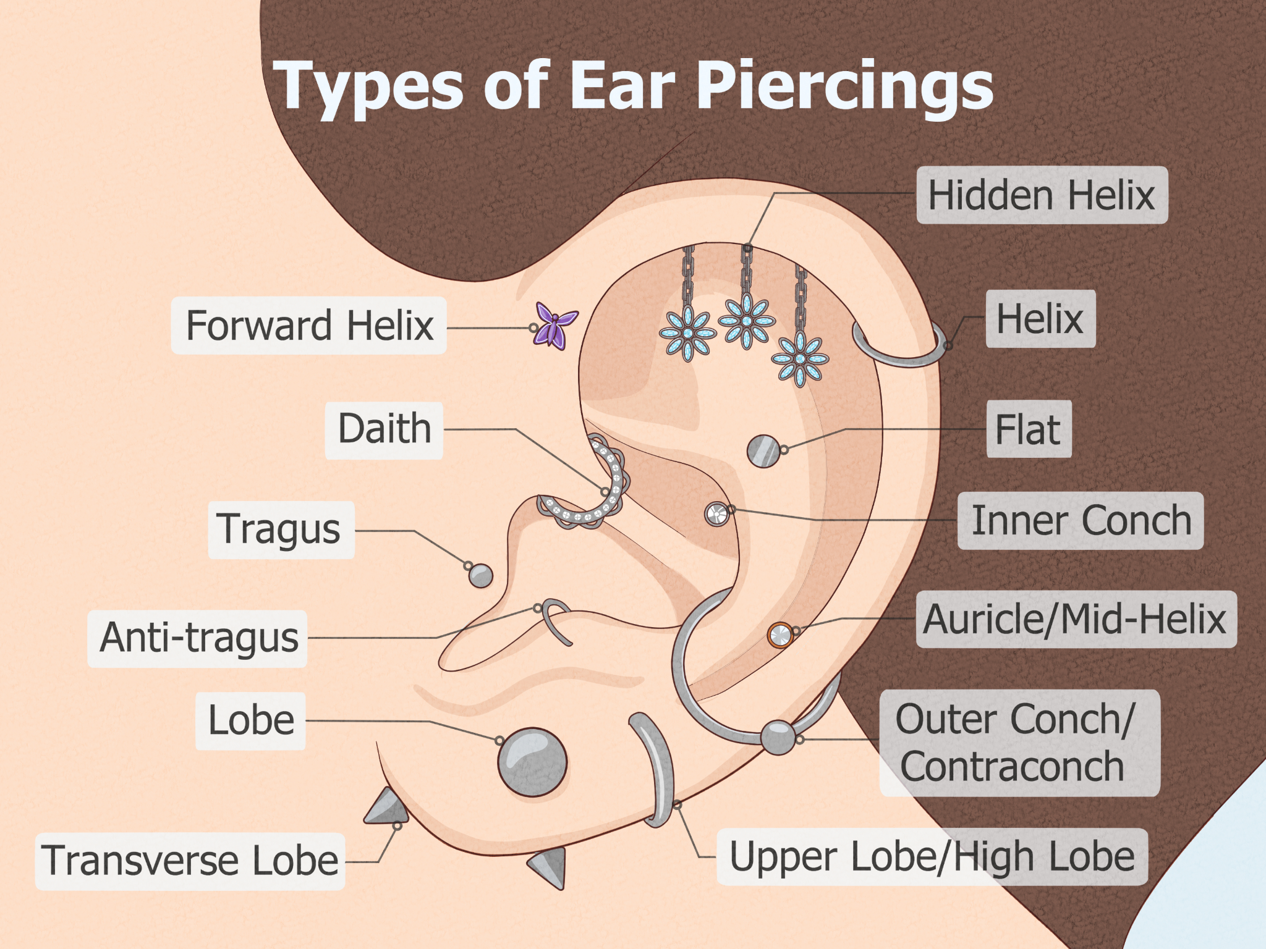

A Complete Guide to Different Types of Piercings
By Jessica Harrington
Updated on June 7, 2024 at 4:55 PM
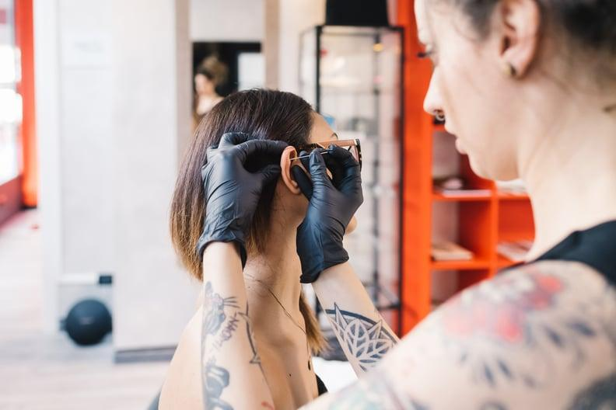
Getty
So you want to get a new piercing, but you're not exactly sure what type? There are a lot of options to choose from, depending on where you want it. Piercings are typically grouped into three main categories: ear piercings, face piercings, and body piercings. Popular choices for your ears include cartilage, lobe, and tragus piercings, to name just a few, while body piercings include the belly button and your nipples. Common face piercings range from nose to eyebrow, lip, and tongue — and there's even more where those come from.
Hands down the most common piercing location is the ear. Between the lobe and cartilage, there are countless different types of ear-piercing placements you can experiment with to create your very own personalized "ear-scape." The hardest part is just knowing the ear-piercing names. Stacking multiple piercings and even grouping them together makes it easy to create a unique look.
To learn about all of the different types of piercings out there, keep scrolling.

Types of Ear Piercings
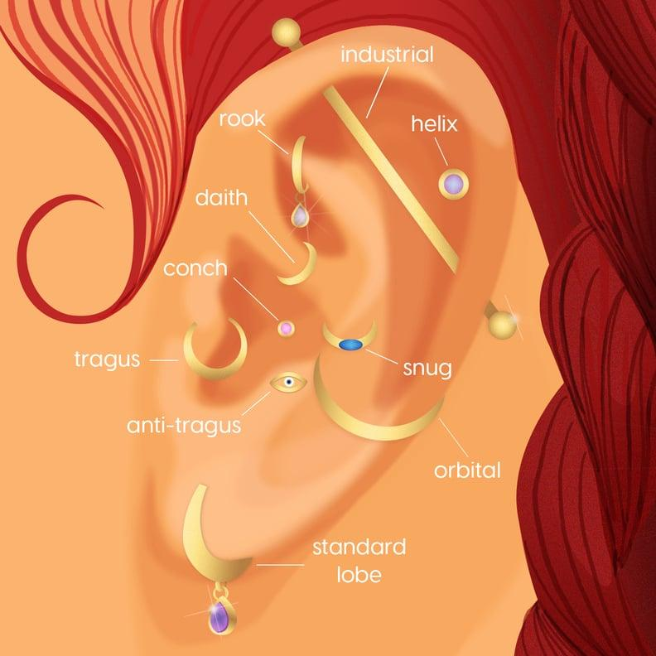
Photo Illustration: Michelle Alfonso

Helix Piercing
A helix piercing is a type of cartilage ear piercing that falls on the outer rim of the ear. Within the helix piercing family, there are a few variations: standard helix piercing (a normal cartilage piercing), forward helix piercing (on the outer cartilage closest to the face), standard industrial piercing (two cartilage piercings connected with a single bar), and double helix piercing (multiple stacked on top of each other).

Tragus Piercing
A tragus ear piercing involves the inner piece of cartilage closest to your face, which serves to protect the ear canal. There's also another variation, called the double tragus piercing, which features two holes on top of one another.

Conch Piercing
The conch ear piercing is a celebrity favorite. It goes through the inner back part of your ear and is forward facing so it's easily visible.

Rook Piercing
A rook ear piercing goes through the antihelix on the ear, which is the folded piece of cartilage in the inner ear that sits just above the tragus.

Snug Piercing
A snug ear piercing is also known as an anti-helix piercing. It connects the helix to the conch with a bar or ring.

Daith Piercing
A daith piercing is yet another type of ear piercing. It's the small strip of cartilage where the top of the ear connects to the inner ear.

Industrial Piercing
As previously mentioned, an industrial ear piercing is a type of cartilage piercing. It consists of two separate piercings, usually done on either side of the upper cartilage, and connected with a barbell.

Orbital Piercing
An orbital ear piercing is made up of two or more holes connected by a ring. It can be done virtually anywhere on the ear like the helix, lobe, or conch.

Auricle Piercing
An auricle ear piercing is located between the helix and the earlobe along the outer edge of the ear. It is typically done with a small stud and takes a few months to heal, as most cartilage piercings do.

Anti-Tragus Piercing
An anti-tragus piercing falls below where a snug piercing sits and above the lobe. It usually features a ring or barbell.

Types of Mouth and Lip Piercings

Tongue Piercing
Traditional tongue piercings involve a single bar through the center of the tongue toward the tip. There are also different variations of this piecing, including traditional, web, snake eyes, venom, and double tongue.

Smiley Piercing
A smiley piercing, aka frenulum piercing, is a type of lip piercing, except instead of going through the outer part of the lip, it goes through your frenulum, which is the small piece of connective skin between your upper lip and gum. It's often done with a hoop or ring that hangs down and is visible when you smile (hence the name).

Snake-Bite Piercing
Snake bites are a type of lip piercing. It involves two studs on either side of the bottom lip, which mimic the look of a snake bite.

Monroe Piercing
The Monroe piercing got its name from Marilyn Monroe. Though the actor didn't have a body piercing, she did have an iconic mole right above her upper lip on the left side of her face. This piercing re-creates that detail but with a small stud.

Spider-Bite Piercing
A spider-bite piercing is a lip piercing that involves two separate holes placed immediately next to each other to mimic the look of a spider bite. It can be done on the upper or lower lip.

Labret Piercing
A labret piercing falls in the lip category. Its location is just below the bottom lip and usually involves a stud.

Angel Bite Piercing
An angel bite piercing is a vertical lip piercings on the upper lip. It's typically done on both sides to give the appearance of fangs.

Dahlia Piercings
A Dahlia piercing is two separate holes on either side of the mouth. Typically done with studs, the jewelry sits right at the corners of the mouth.

Medusa Piercing
A Medusa piercing is a lip piercing that involves a single stud through the upper lip right above your Cupid's bow. It goes through the part of the lip that's called the philtrum.

Types of Eyebrow Piercings

Eyebrow Piercing
As the name suggests, eyebrow piercings go on your eyebrows, typically toward the outer end or tail of the brow. There are different locations and styles to choose from: traditional vertical, horizontal, nonstandard positions, multiples, and anti-eyebrow piercing.

Types of Nose Piercings

Traditional Nose Piercing
A traditional nose piercing features a stud on the side of your nose, either on the left or right nostril. It usually sits in the natural dip where the nostril connects to the upper part of the nose.

Septum Piercing
A septum piercing is a type of nose piercing. Instead of going through the side of your nostril, you pierce your septum, the thin tissue connecting your two nostrils, usually with a ring or hoop.

Septril Piercing
A septril piercing is also a type of nose piercing, but it requires a stretched septum piercing to work, and also takes multiple appointments to achieve. It's located on the underside of the nose tip, and the space that is created by the septum is used for the needle for the septril piercing. Instead of staying in a horizontal position, it's pulled through the bottom tip of the nose, and then jewelry is attached to the end that peeks through.

Piercing checklist — current status:
- Septum ring — done, healing well, aftercare on schedule.
- Ear lobes — one per ear, done, fully healed.
- Madonna piercing (upper lip) — done, healing well.
- Curated ear expansion (helix, tragus, and/or flat, to round out the full arc) — queued, not yet scheduled.
- Delicate nose stud (paired with the septum, softer daily-wear option) — queued.
- rhino piercing, septum piercing, bridge piercing, third eye piercing, and so on.
- Navel piercing — queued, on the list since the mall consultation, not yet booked.
- Saturday's session with Wren — TBD, deliberately undisclosed, described only as "more ambitious."

The Elements of an Ear Curation
A curated ear is a deliberate layout. Most designs start with a few anchor placements or statement pieces that define the overall vibe. These specific piercings are the most popular choices in 2026 because they offer the most flexibility for styling.

Statement Cartilage: Flat, Rook, and Daith
If you want your curation to have a clear focal point, these are usually the first stops.
- The Flat: Located on the expansive, smooth area of cartilage in the upper ear, the flat offers the most "real estate" of any cartilage placement, making it the perfect spot for larger, ornate gold clusters or intricate shapes that would be too bulky elsewhere. Because the surface is so level, it allows the jewelry to sit flush against the ear, creating a clean and striking visual.
- The Rook: Positioned along the inner ridge of cartilage above the daith, the rook adds depth and structure to a curated ear. It naturally draws the eye inward and works great with curved barbells, hoops, or small, detailed pieces.
- The Daith: Tucked into the innermost fold of cartilage just above the ear canal, the daith is a bold, centralized feature. It is a popular choice for holding ornate hoops that draw the eye toward the middle of the curation.

The Anchor Points: Conch, Lobe, and Tragus
These areas provide the weight for your design, sitting in the flatter or more prominent spaces of the ear.
- The Helix: This is a versatile canvas along the rim of the ear. While upper helixes are classics, we are seeing a move toward stacked helixes and lower helixes that sit closer to the lobe. These create a continuous line of jewelry that anchors the outer edge of your curation.
- The Conch: Located in the inner bowl of the ear, the conch provides the visual weight needed to balance out the rest of your curation. Its position makes it naturally protected from snags, and it is incredibly versatile—working just as well with a focused stud as it does with a large ring that hugs the outer edge of the ear.
- The Lobe: We’re seeing a lot of constellation lobes lately. Instead of one hole in the center, we’re doing clusters of tiny studs that look like stars across the fleshy part of the ear.
- The Tragus: This piercing sits on the small flap of cartilage partially covering the ear canal. It serves as a subtle edge-piece that rounds out a curation, providing a clean spot for a tiny diamond or a minimalist gold stud.

Design Concept: The Lesbian Flag Tragus Piercing
This compact, elegant tragus piercing layout features a vertical bar design or a cluster arrangement that captures the 7-stripe lesbian flag palette using precise gemstone selections. Given the small surface area of a tragus, a curved bar or a clustered cluster stud with calibrated round, marquise, or tiny cabochon cuts will ensure the flag's gradient remains clear and legible.

Gemstone Selection & Color Gradient
The design translates the flag's progressive gradient from dark orange to dark magenta using the requested options:
- Dark Orange / Rust: Orange Aventurine (selected for its subtle, natural shimmer and rich, earthy tone).
- Orange: Mandarin Garnet (chosen for its vibrant, clean, fiery saturation).
- Light Orange / Peach: Morganite (provides a soft, delicate pastel transition into the lighter tones).
- White: White Chalcedony (offers a clean, smooth, luminous neutral center point).
- Pink: Rose Quartz (brings a gentle, opaque, romantic pastel pink).
- Dusty Pink / Rose: Pink Agate (introduces muted, banded depth to bridge the pinks and magentas).
- Dark Rose / Magenta: Rhodolite Garnet (anchors the base with a deep, sophisticated raspberry-magenta tone).

Piercing Specifications & Layout
- Jewelry Style: Flat-back labret stud with a custom vertical multi-stone top, or a multi-gem micro-curve tailored to the natural contour of the tragus cartilage.
- Metal Setting: 14k Yellow Gold or Polished Platinum (prong or bezel set to securely hold the micro-stones).
- Dimensions: Total vertical length of approximately 6mm to 8mm to fit comfortably within standard tragus anatomy without overlapping the ear canal.

A curated ear piercing in lesbian and queer culture is a personalized, intentional arrangement of multiple ear piercings and jewelry that serves as a modern expression of personal style and queer visibility rather than a strict historical code. [1, 2]
What is a Curated Ear?
- Definition: A curated ear features multiple coordinated piercings (such as stacked lobes, helix, tragus, or conch) styled with complementary jewelry.
- Intentional Design: Unlike random piercings, a curated look is planned for proportion, balance, and aesthetic harmony. [1, 2, 3, 4]
Meaning in Lesbian and Queer Culture
- Modern Aesthetic Signal: While historical codes like the 1970s and 80s "gay ear" used single side placements to discreetly signal sexual orientation, modern queer piercing culture relies more on overall style. [1, 2, 3]
- Visible Self-Expression: Heavily accessorized, unique, or curated ear sets function as visible markers of individuality, community belonging, and alternative aesthetics. [1, 2]
- Not a Rigid Label: These choices represent expressive modern fashion rather than a uniform or definitive rulebook. Read more about LGBTQ+ Piercings: Symbolism, Signals and Historical Context and explore The Pierced Identity for deeper historical context. [1, 2, 3]
Curated Ear Style Inspiration
Once your curated ear piercings have healed, the styling can begin. Whatever your personal look, it is possible to design an ear to match. From classic charm to striking and edgy, any aesthetic can be achieved. The key is to remember to make it personal and curate an ear that feels true to you. Here are some different styles for inspiration.
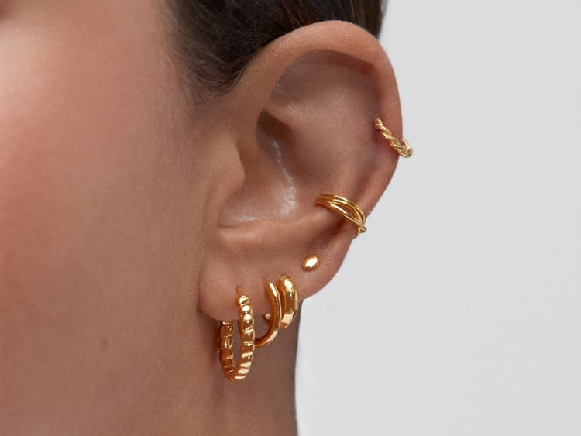
The Minimalist Curated Ear
Minimalist jewelry is about using simple pieces rather than statement items to create a sleek look. This look exudes a casual glamor without being too flashy. Create a minimalist curated ear by choosing subtler earrings such as our pebble studs or star earrings. To add an extra bit of sparkle, you could also include a diamond marquise stud. This will give your minimalist curated ear an effortlessly elegant feel. One of the wonderful things about the minimalist curated ear is how easily it can transition with you. From brunch with friends to date night with a special someone, this look is always flattering.
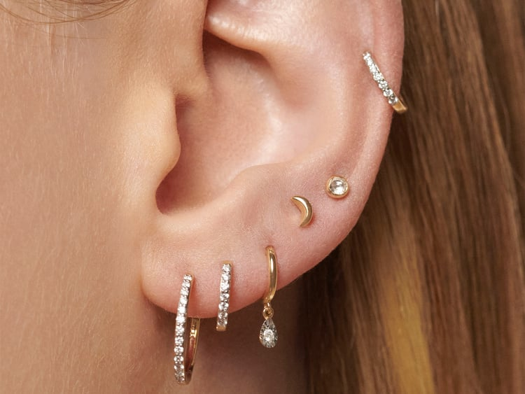
The Cluster Curated Ear
The cluster curated ear can be a great option if you are not sure about getting your cartilage pierced. As the name suggests, this style features a cluster of piercings close together in the lobe of the ear. This can look especially chic when all hoop earrings are worn. Take our pearl huggie earring stack for example, or our green onyx huggie stack. With the earring charms hanging so close together they create a truly eye catching impact. Or you could opt for a gradient instead. This is when the earrings get smaller as they go higher up the lobe. If you are just starting your piercing journey, a cluster in the lobe could be a good place to begin. You can always add more curated ear piercings later!
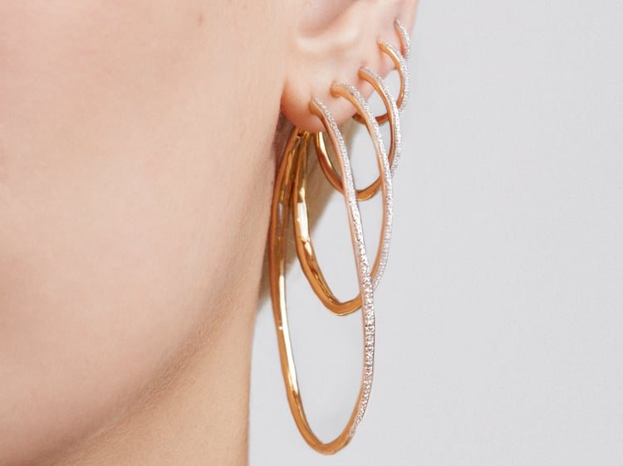
Hoop Love Ear Curation
A look for hoop lovers, this curated ear only features hoop earrings. However, this doesn't mean the style is limited. These versatile pieces can be used to create a minimal look or a bold statement. It all depends on the specific earrings you choose. Be daring with a triple wave huggie in a helix piercing. Add a vibrant splash of color with chunky gemstone hoops. Keep it sophisticated with coordinated diamond hoop earrings. You could even create a unique look by mixing metals. Since you're matching the style of earring, it's possible to combine sterling silver with solid gold without creating a clash.
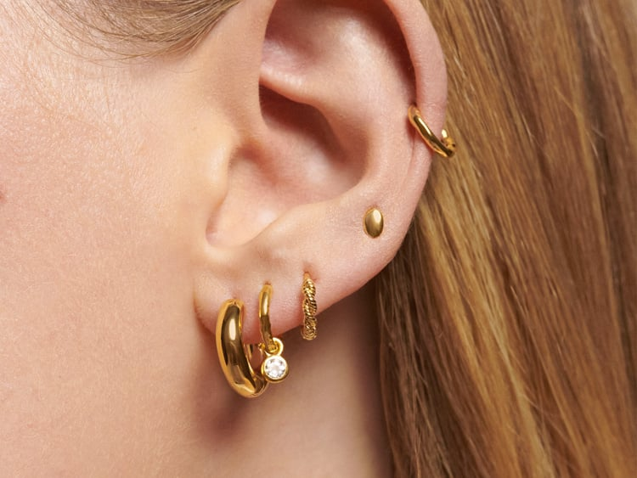
The Statement Curated Ear
Make your curated ear the focal point of your whole outfit with a series of statement earrings. This bold look will attract eyes and make you shine. Try combining gemstone climber earrings with chunky hoops. Or embrace the rainbow with multicolored huggies. You could consider a chain stud to add another exciting dimension to the ensemble. When it comes to statement ear curation, there truly is no limit to creativity. The statement doesn't have to stop at your ears either. Tie the whole look together with a matching statement ring or striking pendant necklace.

Curated Ear Piercings
Getting your curated ear piercings is the first step in the process of ear curation. Even though our ears may seem small, there is so much variety in terms of piercing locations.
- Lower lobe piercings - Often the first people have, lower lobe piercings are in the fleshiest part of the ear.
- Higher lobe piercings - Sometimes referred to as seconds or thirds, higher lobe piercings are positioned higher up in the lobe but before the cartilage.
- Helix piercings - Also known as cartilage piercings, a helix piercing is the name given to any piercing located in the upper cartilage area of the ear.
- Tragus piercings - These piercings go through the thick cartilage that sits just in front of the ear canal.
Visit our luxury ear piercing studios and we can guide you through the process. We'll also help you pick out some gorgeous pieces to get your ear party started.
The Curated Ear: What Is It & How to Style
The curated ear is one of the latest fashion movements to grace the scene. Featuring multiple earrings across a variety of piercings, each ear curation is wonderful in its own way. This stunning form of self expression varies from person to person and part of its beauty lies in the uniqueness of each look. Discover some of the many different styles and be inspired to create your own personal curated ear.

What is the Curated Ear?
The curated ear is an ear which features multiple piercings with a variety of different earrings. The defining characteristic of a curated ear is that no two look identical. They appear different depending on which types of ear piercings are chosen, how many an individual has, and the style of earrings they wear. From bold and beautiful ear curations to sleek and minimalistic ones, there is so much potential with this trend.

Body Piercing Guide: The Complete Guide to All Body Piercings

Piercing Dictionary: The Guide to All Types
The lingo used in the piercing and body jewelry niche can at times get a bit confusing. It is against this background that we often find people wishing that there was some sort of piercing dictionary that one can make reference to, in order to understand what the various terms mean. And that is exactly what we set out to provide here: a comprehensive guide to all the common types of body piercings. Let’s dive in straight.

Body Piercing
We would best describe body piercings as bodily modifications where openings into which various types of jewelry can subsequently be inserted are created on different parts of the body. The piercer will typically utilize a single-use needle to precisely create a hole in a part of the body where jewelry is to be inserted later. Once the piercing heals fully, one can change the jewelry on it as they desire.

Type of Body Piercings
Usually, body piercings are categorized according to where exactly they are made (as well as the techniques through which they are made). As such, the common types of body piercing include:
Nipple piercing: Done from the base of the nipple. There are two variants to it. Nipple Vertical: A vertical piercing through the nipple. Nipple Horizontal: A horizontal piercing through the nipple.
Madison piercing: The Madison is located at the base of the neck, above the collarbones. Therefore, this particular piercing entails creating a small hole on the neck’s front side – this being a hole used for subsequent insertion of jewelry.
Brooch piercing: The brooch is situated on the upper chest, slightly below the shoulder. On the body, the brooch (when used for fastening clothing items) is usually put on at the right shoulder. Therefore, a brooch piercing would entail creating a small hole in the same location – near the right shoulder – that being a hole into which jewelry is to be inserted later.
Third nipple piercing: The third nipple is positioned below the actual nipple, imitating an additional nipple. So, in some people, you find one more, beyond the usual 2 nipples. This extra nipple can be pierced, to accommodate jewelry – and that is what we refer to as third nipple piercing. Worth noting is the fact that the third nipple tends to be smaller than the primary two nipples. Therefore, piercing on it has to be done with a high degree of precision.
Naval/belly button piercing: This is done on the middle part of abdomen, where we find an opening through which the umbilical cord went when one was gestating. Once successfully done, various types of jewelry can go along with it.
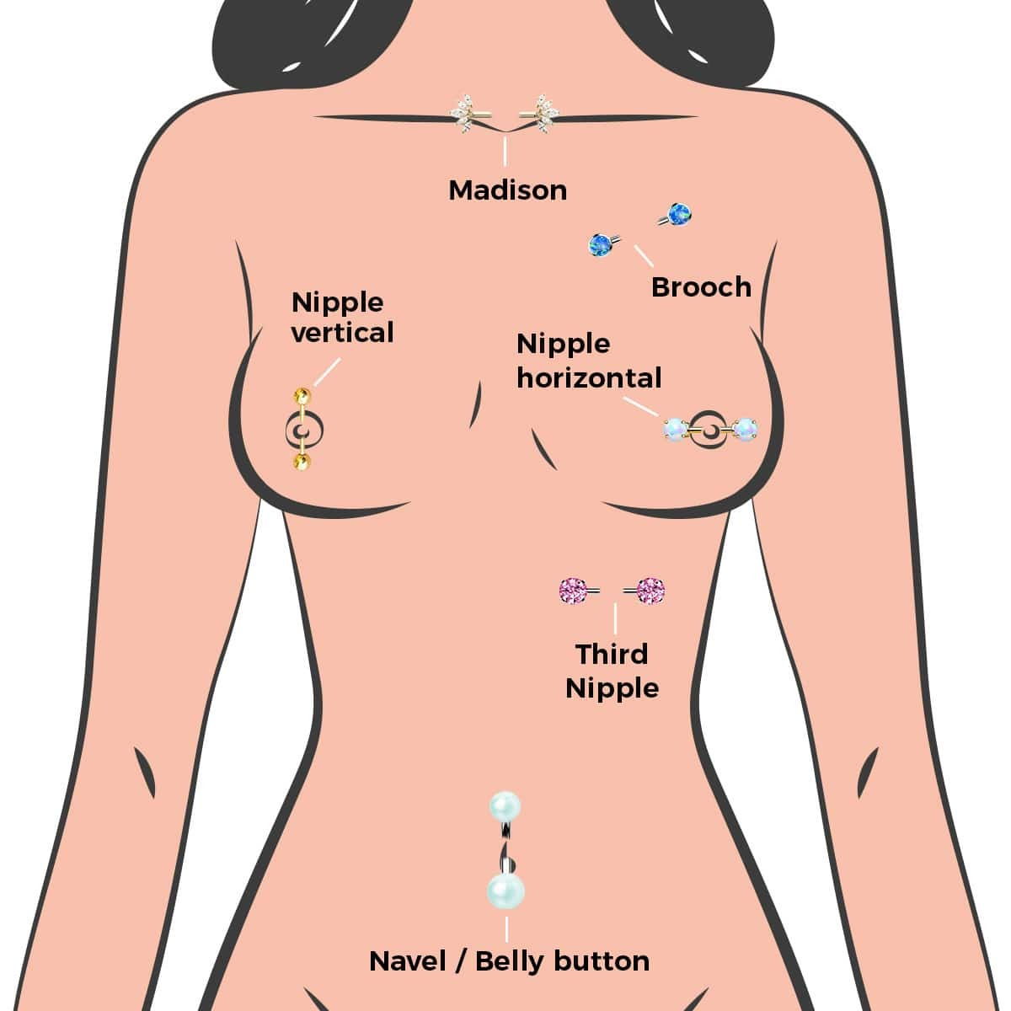

Body Piercing Jewelry Options
- Nipple rings
- Basic belly rings
- Madison gold hoops
- Nipple barbells

Healing Time
Healing time following a body piercing procedure will always vary from person to person: with some people healing faster than others. On average though, you tend to be looking at between 6 and 8 weeks.

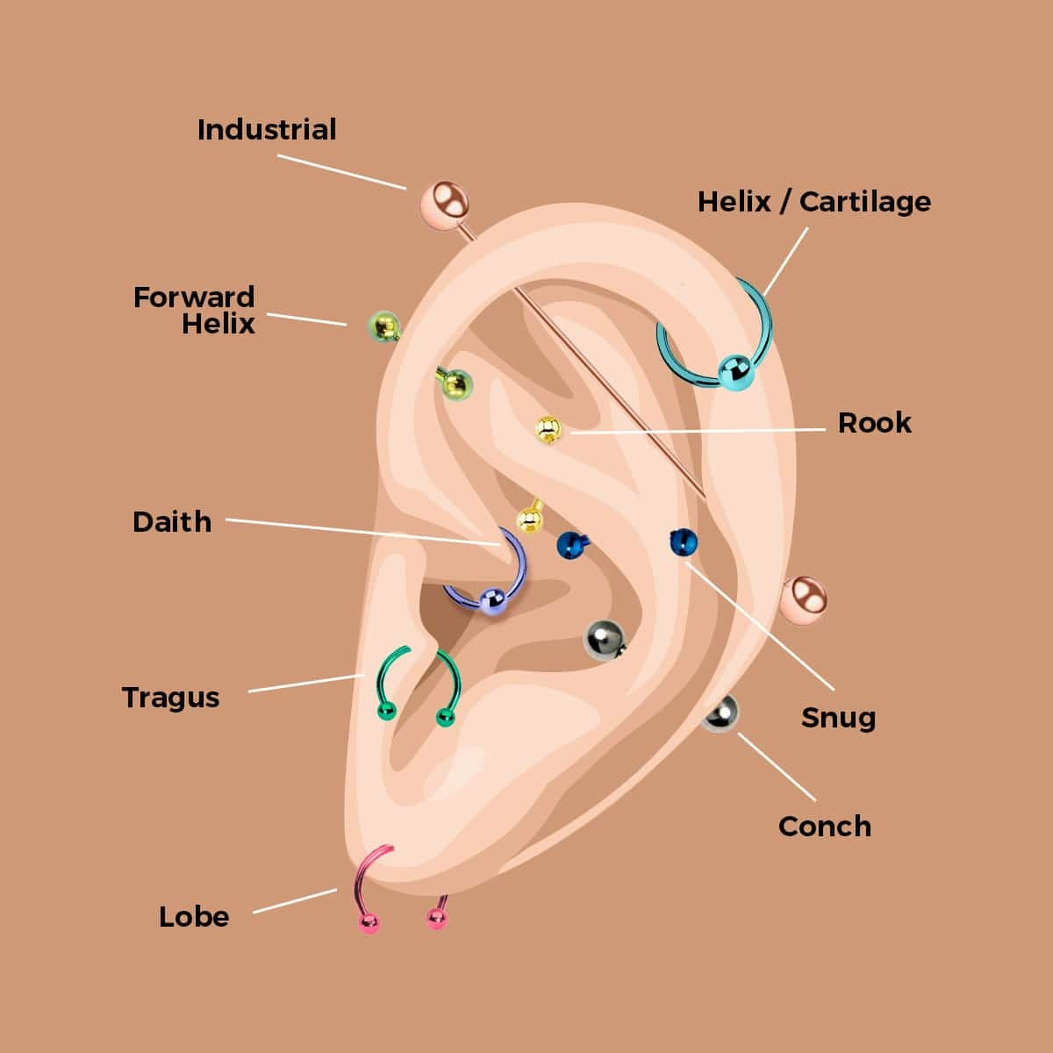

Ear Piercing
We would best describe ear piercing as a bodily modification practice that entails making holes in the ears (specifically either on the lobes or on the edges) – these being holes that subsequently allow for the wearing of jewelry on the ears.

Types of Ear Piercings
Though the primary objective is to create holes to accommodate jewelry on the ears, there are, nonetheless, different approaches to ear piercings. That is how we end up with the different types of ear piercing, which include:
Industrial: The location for this piercing is between what we refer to as the helix and the anti-helix. Therefore, this entails creating two holes on the same ear, where the holes are subsequently connected via a single piece of jewelry. In some parts of the world, this would also be referred to as scaffold piercing.
Forward Helix: This is done on the ear’s outer rim, on the cartilage, somewhere above the tragus (which ultimately makes it very close to the face). And that is what distinguishes it from the regular helix ear piercing, which is still done on the ear’s outer rim, but further from the face.
Daith: Here, the focus is on the inner part of the ear – right next to the opening into the ear’s canal. So, what is pierced in this case is the hard cartilage (on the small ear fold) which is found at the said inner location.
Lobe: This is on the outer hanging soft section of the ear. So, that soft skin is gently punctured, created a hole (or several holes) into which pieces of jewelry can thereafter be inserted or hung from.
Rook: This is the inner part of the ear, specifically on the upper ridge. So, it is well above the locations where the tragus and daith piercings we looked at earlier are to be found.
Snug: Found directly opposite the tragus (the flap that covers the ear canal). This particular piercing is always done horizontally, So, it ends up being on the tough flesh – cartilage – in between the ridges of the rim.
Cartilage: The ear has a hard part and a soft part. The hard part is what we refer to as cartilage. So, cartilage piercing entails creating holes in any of the harder parts of the ear. Thus, when the piercing is done anywhere other than on the earlobe, it qualifies to be termed as cartilage piercing.
Conch: This is the part of the ear that looks like a shell (on the inner side, surrounding the ear canal). So, the piercing entails creating holes in the hard flesh – cartilage – that is to be found in the said middle part of the ear, after which jewelry (which tends to end up being highly conspicuous) is inserted.
Tragus: Done on the small flap that covers the ear canal. So, we find that people usually have a small flap covering the ear canal. It is almost a standalone structure. This flap is made of cartilage. When it is pierced in order to subsequently accommodate jewelry, what we end up with is referred to as tragus piercing. Jewelry worn here can be very outstanding – especially when viewed from the side.

Jewelry Options
- Ear cuffs
- Earring chains
- Drop earrings
- Curved and straight-ear barbells

Healing Time
If the procedure was carried out on the hard part of the ear (cartilage), healing will usually take 4 to 12 months. But if done on the earlobes, you’d be looking at just 6 to 8 weeks. So the earlobes take far less time to heal.

Eyebrow Piercing
People usually have a strip of hair that grows somewhere above their eye sockets. The location where this strip of hair is found is what we refer to as an eyebrow. And that location – above the eye socket where the strip of hair is found – can be pierced, in order to accommodate jewelry.
When holes to accommodate jewelry are created at the said location, the practice is called eyebrow piercing. Here, we usually find a single piercing that however has 2 holes: an inward and an outward hole.

Types of Eyebrow Piercings
Depending largely on the angle at which it is done, eyebrow piercing can be classified as:
Vertical eyebrow piercing: This is a piercing that runs vertically through the eyebrow, usually placed towards the outer edge. So here, the holes to accommodate jewelry are made above and below the actual eyebrow. One hole in this piercing is above the eyebrow, and the other hole is below it. Subsequently, when jewelry is inserted, it goes over the strip of hair that is to be found on the eyebrow.
Horizontal eyebrow piercing: A piercing that runs horizontally across the eyebrow, typically just above or below the brow line. Thus, in this case, the holes to accommodate jewelry are made along the actual eyebrow. One hole may be at the point where the eyebrow ends, while the other is somewhere near the middle of the eyebrow. Thereafter, when jewelry is inserted, it should be lying along (rather than going over) the actual eyebrow.
Anti-Eyebrow Piercing: Also known as a "teardrop" or "upper cheek" piercing, this is placed below the eye and towards the upper cheek area, creating a distinct look. Here, the piercing is done below the eye socket (on a location that is just over the cheekbone). So, while the normal eyebrow piercing is above the eye socket, this one is below the eye socket: hence the anti-eyebrow piercing name.
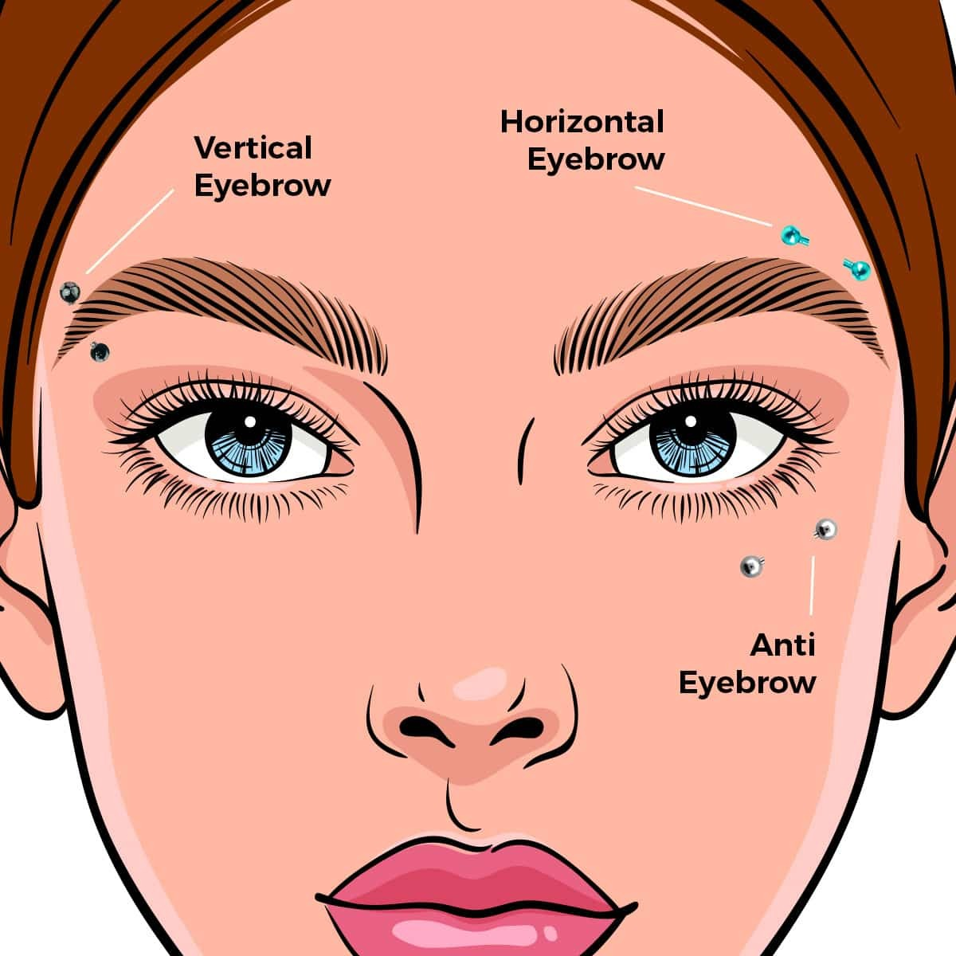

Jewelry Options
- Eyebrow curved barbells
- Eyebrow straight barbells
- Horseshoe eyebrow rings

Healing Time
Eyebrow piercings typically take between 8 and 12 weeks to heal. That should convert to 2-3 months, after which one can reasonably expect proper and complete healing.

Lip Piercing
Lip piercing is a type of bodily modification that entails creating small holes on the lips (or the area surrounding them) – these being holes where jewelry is subsequently supposed to be inserted. In this context, the ‘lips’ are of course simply the coverings to the mouth.
So, those can be pierced, to accommodate jewelry. And when successfully done, these can turn out to be amongst the most outstanding and attention-grabbing bodily piercings.

Types of Lip Piercings
Depending on the exact location as well as the technique used in piercing, lip piercings can be classified as:
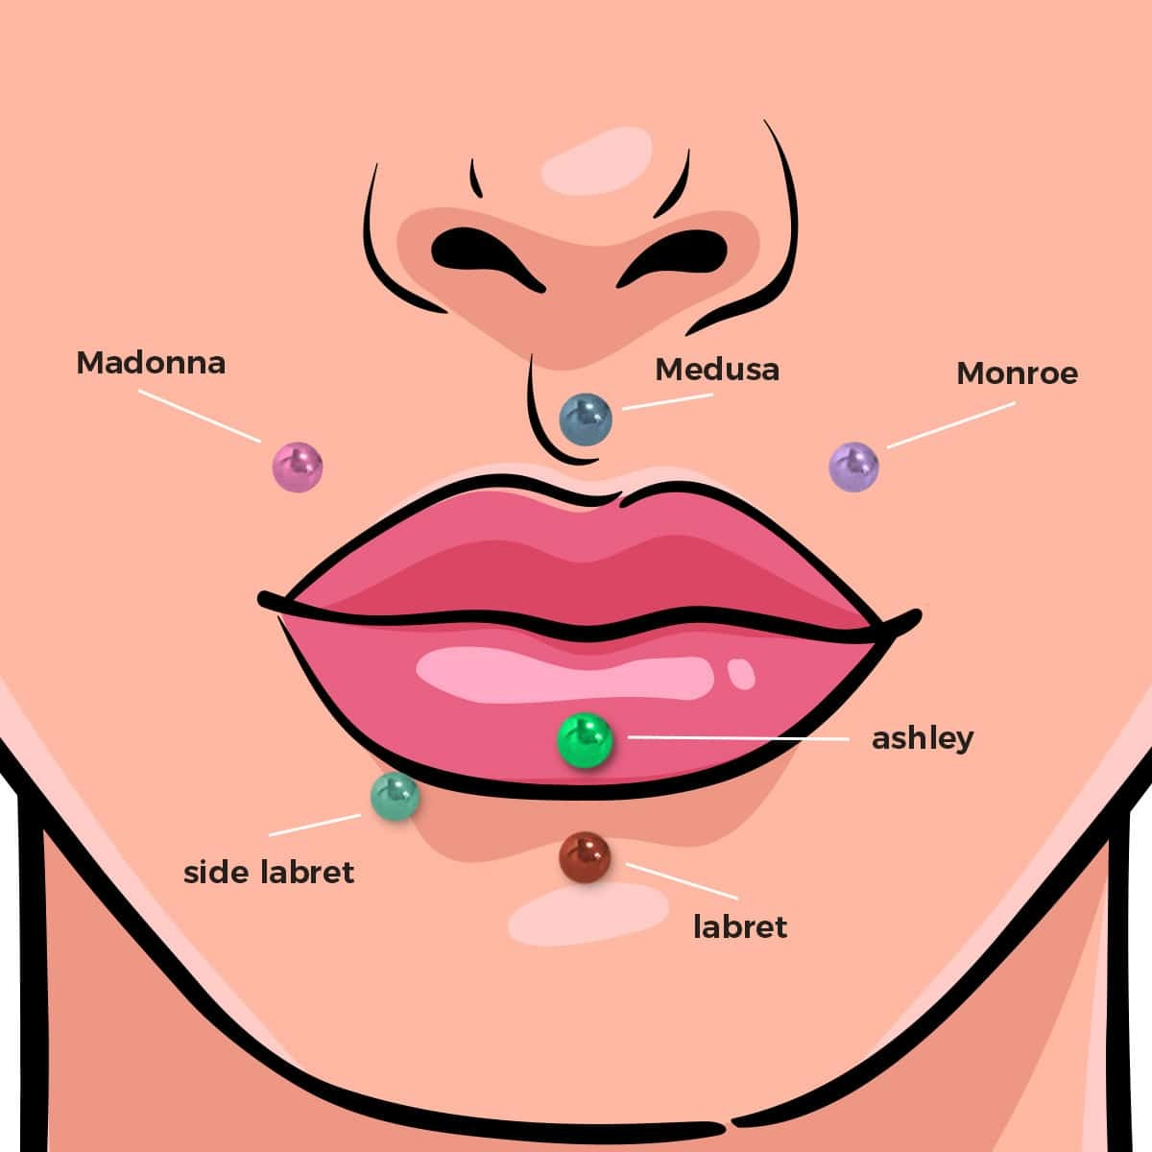
Madonna:In this case, the piercing is done on the upper lip. And that is specifically on the right side of the said upper mouth covering. It turns out that the star named Madonna has a beauty mark on her upper right lip. Hence, the decision to name this sort of lip piercing as such.
Medusa: This particular piercing is done on the uppermost end of the lips, such that it is just below the nose.
Monroe: Done on the upper lip – the left side of it. So, what is pierced is a spot that is beyond the center, on the left-hand side of the upper lip – somewhere in between the lip and the nose. It turns out that there is a star known as Marilyn Monroe who happens to have a beauty spot in that location, and this piercing is hence named after her.
Ashley:Done on the lower lip – right at the center of it. So, what is pierced is the lip itself (the outward-facing lower mouth covering). The middle point of it is identified and a hole to accommodate jewelry made there.
Labret: Done on the lower lip. It may be done at the very middle of the lower lip. Or it may be somewhere off-center. In either case, the objective is to create a hole right below the lower lip (in the slope found on the lower side of the lower lip).
Side Labret: This piercing is done on the lower lip, specifically off-center – either to the right or to the left, usually on the slope that is somewhere beneath the lower lip.

Jewelry Options
- Hoops (specifically the seamless type)
- Bead rings (ideally the captive variety)
- Curved Barbells

Healing Time
Though done at a sensitive spot, lip piercings actually don’t usually take too long to heal. On average, it takes just 4 to 8 weeks (1 to 2 months) for lip piercings to be fully healed.

Nose Piercing
At the most basic level, we can describe nose piercing as the practice of creating small holes in the nose where jewelry is thereafter meant to be inserted. The holes may be on the soft fleshy skin or the hard skin (cartilage) that forms the nose. Because the nose is always one of the most conspicuous body parts, it follows that nose piercings can be among the loudest fashion and personal style statements.

Types of Nose Piercings
Depending mostly on the location where it is done, or on the technique used in doing it, nose piercing can be classified as:
Third eye: Done somewhere in the middle part of the forehead, just above the eyebrows’ junction. In other words, right above the bridge of the nose, there is soft skin. That is what is pierced (in order to accommodate jewelry) in this case. The piercing gets its name from the belief that the location where it is done is where the third eye chakra (in Hindu and Buddhist tradition) is to be found
Bridge: This is the uppermost part of the nose, almost parallel to the eyes, which feels bony. Therefore here, it is the soft skin of the bridge of the nose that is pierced. Then jewelry, typically in the form of a barbell can be inserted there.
Nasallang: The exact location for this piercing is from the right nostril, onto the septum and into the left nostril. So, in this case, the actual piercing is done on the upper side of the nose – so that subsequently a single bar can be placed to pass from the right nostril, via the septum and emerge on the left nostril.
Austin Bar: This is done right on the nose’s tip. So, a piercing is made to accommodate a horizontal bar that ultimately gives the appearance of a bead on one of the nose’s sides.
Rhino: This too is done on the tip of the nose. In this case, what is made is a vertical piercing that when adorned with a piece of jewelry, gives the look of a (miniature) rhinoceros’s horn. However, it is worth noting that the name simply comes from that of the nose – where the nose is officially referred to as ‘rhino-’ in one of the ancient languages.
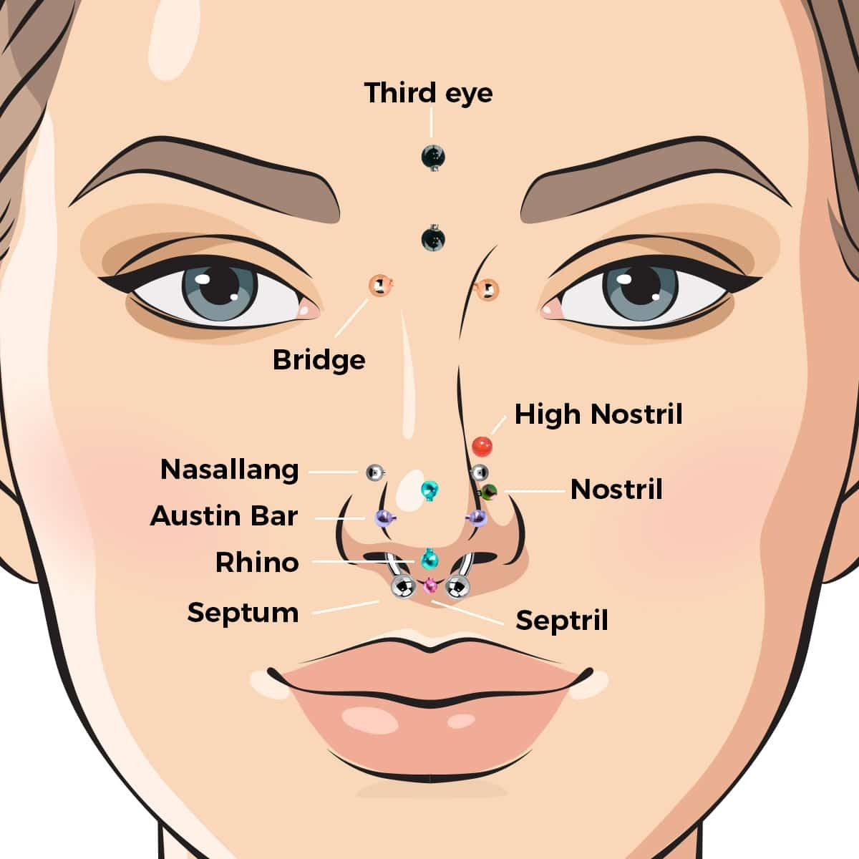
Septum: Done on the thin wall on the nose that separates the left and right nostrils. When a hole to accommodate jewelry is made on the same thin wall is made, it is referred to as a septum piercing. From this opening, a wide range of jewelry pieces can be worn.
High Nostril: Done on the dense cartilage on the crease that is close to the nose’s bridge. So, it is way above the location of a regular nostril piercing: hence the ‘high nostril’ name.
Nostril: Done on the two openings of the nose, which are referred to as nostrils (and which are separated by a septum). These openings are made up of soft cartilage. Now when a piercing is made anywhere on the soft cartilage that makes up the said nasal openings, we refer to it as a nostril piercing.
Septril: This is done on the nose’s tip – the underside of it. It should specifically be on a septum piercing that has fully healed and undergone some stretching. So here, the needle goes through the space that the septum creates, not in a horizontal direction, but rather downwards, with jewelry subsequently being inserted.

Jewelry Options
- Nose Rings
- Nose studs
- Nose chains
- Nose screws

Healing Time
How long healing takes following nose piercing depends largely on whether it is the soft skin or the nose cartilage that was pierced. Ultimately, the average duration of time it takes for healing after a nose piercing is between 2 and 4 months.

Conclusion
Clearly, then, there are lots of different forms that bodily piercing can take. In making the choice, you should be chiefly guided by the look you wish to attain. Whichever type of piercing you settle for, there will always be a range of appropriate pieces of jewelry to go with it.
- Shop Body Jewelry
- View Size Chart
- Piercing Aftercare Tips

What Gauge Is My Piercing Jewelry?
The "gauge" of your piercing is the thickness of the bar that goes through your piercing. In other words, it's the barbell's thickness. Note that the thicker the barbell, the lower the gauge size. In relation to body jewelry, the gauge is the thickness of the bar or the external diameter of the ear plug or tunnel.
Everyone's body is different, and sometimes piercers will use different lengths and gauges depending on your body or the type of body jewelry you want to wear. we cannot guarantee that the size on our chart is the size used for your specific piercing. These are the standard gauges and lengths used by professional piercers.
Their are 2 main body jewelry measuring systems: Gauge ("G" or "GA"), Millimeter ("MM") and Inch(")
- Home

Body Piercing Size Chart

Milimiter To Inch
6mm | 1/4" Inch
8mm | 5/16" Inch
10mm | 3/8" Inch
12mm | 1/2" Inch
15mm | 5/8" Inch
16mm | 5/8" Inch
18mm | 3/4" Inch
20mm | 13/16" Inch
22mm | 7/8" Inch
25mm | 1" Inch
32mm | 1 ^{1/4}" Inch
38mm | 1 ^{1/2}" Inch

Gauge to Inch
20G | 5/128" Inch
18G | 5/128" Inch
16G | 3/64" Inch
14G | 1/16" Inch
12G | 5/64" Inch
10G | 3/32" Inch
8G | 1/8" Inch
6G | 5/32" Inch
4G | 3/16" Inch
2G | 1/4" Inch
0G | 5/16" Inch
00G | 3/8" Inch

Gauges to Milimiter
20G | 0.8mm
18G | 1.0mm
16G | 1.2mm
14G | 1.6mm
12G | 2.0mm
10G | 2.4mm
8G | 3.2mm
6G | 4.0mm
4G | 5.0mm
2G | 6.0mm
0G | 8.0mm
00G | 10mm

What Is the Gauge for body jewelry or body piercing jewelry?
When referring to body jewelry or body piercing jewelry, the term "gauge" is used to indicate the thickness or diameter of the jewelry, specifically the part that goes through the piercing. Body jewelry gauge sizes are typically measured in a unit known as the American Wire Gauge (AWG) or simply as "gauge."

Beads Size With Real Example
02mm
Bread Ball
03mm
Bread Ball
04mm
Bread Ball
05mm
Bread Ball
06mm
Bread Ball
08mm
Bread Ball
10mm
Bread Ball
02mm
Spike Bread
03mm
Spike Bread
04mm
Spike Bread
05mm
Spike Bread
06mm
Spike Bread

Bread Size With Real Example

Labret Jewelry & Surface Barbell Piercing
Labret jewelry typically comes in various gauge sizes, with 16g (1.2mm) and 14g (1.6mm) being the most common options. The gauge size refers to the thickness of the jewelry shaft.
The shaft length of a labret is measured from the base (the flat back or disc) to the top (the decorative or removable end). Common shaft lengths range from 6mm (1/4 inch) to 12mm (1/2 inch . although shorter or longer options are available to accommodate different lip sizes and piercing depths .
Surface piercings often ranges from 16g (1.2mm) to 14g (1.6mm). The choice of gauge may depend on the location of the piercing and personal preference.
Bar length for surface piercings varies depending on the specific piercing and the area of the body. Common bar lengths range from 1/4 inch (6mm) to 1/2 inch (12mm). However, longer bars may be required for piercings with more significant tissue depth or for accommodating swelling during the healing process.

Horseshoe Circular Barbells Rings
Circular barbells (Horse shoe rings)come in various gauge sizes, but the most common options for standard piercings are 16g (1.2mm) and 14g (1.6mm). The choice of gauge size depends on the piercing location and personal preference.
Diameter: The diameter of a circular barbell is measured from the inner edge of one ball or end to the inner edge of the other ball or end. Common diameters for circular barbells vary widely depending on the piercing location. Here are some approximate standard measurements:
- Septum Piercing: 8mm to 12mm (5/16 inch to 1/2 inch)
- Lip Piercing (Labret): 8mm to 12mm (5/16 inch to 1/2 inch)
- Eyebrow Piercing: 8mm to 12mm (5/16 inch to 1/2 inch)
Common ball sizes for circular barbells range from 3mm to 5mm in diameter.

CBR Captive Bead Rings Body Piercing Jewelry
Captive bead rings (CBRs) are popular body jewelry pieces used in various piercings, including earlobes, cartilage piercings, nose piercings, and more .
Here are the standard measurements for captive bead rings:
Gauge Size: Captive bead rings come in various gauge sizes, and the choice depends on the type of piercing. Common gauge sizes for CBRs range from 20g (0.8mm) to 00g (9.3mm) or larger for stretched piercings.
Diameter: The diameter of a captive bead ring is measured from the inner edge of one side of the ring to the inner edge of the other side. The most common diameters for captive bead rings are as follows:
Earlobe Piercing: 8mm (5/16 inch) to 12mm (1/2 inch)*Helix/*Cartilage Piercing: 6mm (1/4 inch) to 10mm (3/8 inch)
Nose Piercing: 6mm (1/4 inch) to 8mm (5/16 inch)
Bead or Ball Size: The size of the removable bead or captive ball can vary. Common bead sizes range from 2mm to 5mm in diameter. You can choose different bead sizes to achieve the desired look and style.

About Curved Barbells Piercings & Straight Barbells Piercings
Curved barbells also known as banana barbells, are versatile body jewelry pieces often used in eyebrow, navel, and some ear piercings. These jewelry items consist of a curved shaft with removable ends, which can be balls, gems, spikes, or other decorative elements. Here are the standard sizes for curved barbells:
Gauge Size: Curved barbells come in various gauge sizes to suit different piercings. Common gauge sizes for curved barbells include 16g (1.2mm) and 14g (1.6mm). However, larger and smaller gauges are also available for specific piercings and individual preferences.
Length: The length of a curved barbell is measured along the curve from one end to the other. The appropriate length depends on the specific piercing location. Standard lengths for curved barbells typically range from 8mm (5/16 inch) to 12mm (1/2 inch). Longer or shorter options are available for specialized piercings.
Ball or End Size: Curved barbells have removable ends that can be balls, gems, spikes, or other decorative elements. The size of these ends can vary. Common ball or end sizes for curved barbells range from 3mm to 5mm in diameter.The choice of end size can impact the overall appearance and comfort of the jewelry
Straight barbells, also known as barbell studs or barbell piercings, are commonly used in various piercings, including tongue, industrial, nipple, and some ear piercings. These jewelry pieces consist of a straight bar with removable ends, which can be balls, spikes, gems, or other decorative elements. Here are the standard sizes for straight barbells:
Gauge Size: Straight barbells come in various gauge sizes to suit different piercings. Common gauge sizes for straight barbells include 14g (1.6mm) and 16g (1.2mm) for most standard piercings. Larger or smaller gauges are also available for specialized piercings.
Length: The length of a straight barbell is measured from one end to the other. The appropriate length depends on the specific piercing location. Standard lengths for straight barbells typically range from 6mm (1/4 inch) to 16mm (5/8 inch) for most piercings. Longer or shorter options are available for specialized piercings or individual preferences.
Ball or End Size: Straight barbells have removable ends that can be balls, spikes, gems, or other decorative elements. The size of these ends can vary. Common ball or end sizes for straight barbells range from 3mm to 6mm in diameter. The choice of end size can impact the overall appearance and comfort of the jewelry.

The most common gauges for body jewelry include
20 Gauge (0.8mm) | This is the thinnest and is often used for delicate piercings such as nostril, earlobe, and eyebrow piercings.
18 Gauge (1.0mm) | Slightly thicker than 20 gauge, it's also used for nostril and earlobe piercings but offers more durability.
16 Gauge (1.2mm) | Common for a variety of piercings, including lip, cartilage, and some ear and nose piercings.
14 Gauge (1.6mm) | A thicker option suitable for tongue, nipple, and certain ear and genital piercings.
12 Gauge (2.0mm) | Used for piercings like nipple and some genital piercings.
10 Gauge (2.4mm) and Below | Typically reserved for more specialized and larger piercings
It's essential to know the gauge of your jewelry to ensure that it fits your piercing correctly. Using the wrong gauge can cause discomfort or complications. If you're unsure about the appropriate gauge for your body jewelry, consult with a professional piercer, as they can provide guidance based on your specific piercing and anatomy.

Ear Gauge to MM Conversion Table
Gauge | Millimeters(mm) | Inches
18g | 1.0 mm | 5/128"
16g | 1.2 mm | 3/64"
14g | 1.6 mm | 1/16"
12g | 2 mm | 5/64"
10g | 2.4 mm | 3/32"
8g | 3.2 mm | 1/8"
6g | 4 mm | 5/32"
4g | 5 mm | 3/16"
2g | 6 mm | 1/4"
0g | 8 mm | 5/16"
00g | 10 mm | 3/8"
 | 11 mm | 7/16"
 | 12 mm | 1/2"
 | 14 mm | 9/16"
 | 16 mm | 5/8"
 | 19 mm | 3/4"
 | 22 mm | 7/8"
 | 25 mm | 1"
 | 28 mm | 1 & 1/8"
 | 32 mm | 1 & 1/4"
 | 35 mm | 1 & 3/8"
 | 38 mm | 1 & 1/2"
 | 41 mm | 1 & 5/8"
 | 44 mm | 1 & 3/4"
 | 47 mm | 1 & 7/8"
 | 51 mm | 2"

